Open Source Wireless Sensor System

ECE 412 / 413

Sponsor: Dr [David Burnett](mailto:dburnett@pdx.edu)

Advisor: Dr John Acken

Team: Adam Dezay, Manuel Garcia, Brandon Hippe, Mercedes Newton

# **Table of Contents**

**Table of Contents** **1**

**1. Executive Summary** **2**

**2. Background** **2**

**3. Project Overview** **2**

**4. Product Design Specification** **3**

4.1 Concept of Operation / User stories 3

4.2 Stakeholders 3

4.3 Specifications 4

4.4 Requirements 4

4.5 Deliverables 4

4.6 Initial Product Design 5

4.7 Verification plans 9

**5. Project Management Plan** **10**

5.1 Timeline, with milestones 10

5.2 Budget and Resources 11

5.3 Intellectual Property Discussion 12

5.4 Team and development process 12

**6. Appendices** **13**

6.1 Configurations sorted by lowest power consumption / sampling rate 13

6.2 CO2 Sensor Comparisons 16

6.3 PM2.5 Sensor Comparisons 17

6.4 Airflow Sensor Comparisons 18

**Proposal Outline and Discussion**

## **1. Executive Summary**

Air quality is very important for safe working conditions. Just like we use smoke detectors to monitor our environment for risks, we should be able to monitor other air pollutants, such as CO2 and fine particulate matter (PM 2.5), as well as airspeed and direction. Our goal is to build a device to monitor elevated or dangerous quantities of these pollutants using as many open-source components as possible. We aim to create 10 wireless, battery powered initial prototypes that have at least one year life span.

## **2. Background**

We want to make it easy to continuously monitor an indoor environment, and report data back to a host. We can make it easy by making cheap, reliable devices that don't need recharging for a long time. Three features of indoor air are expected to be monitored: 2.5 μm particle count or PM2.5, carbon dioxide (CO2) concentration, and ventilation air speed.

Regarding CO2, Statistically significant decrements occurred in cognitive performance

(decision making, problem resolution) starting at 1000 ppm. It is also a

good proxy for ventilation; high CO2 levels mean the room is poorly ventilated, which increases

the risk of passing airborne diseases such as COVID.

Regarding PM2.5, the WHO recommends an upper limit of 5 ug/m3 (microgram per cubic

meter) average annually and 15 ug/m3 average over a 24 hour period .

An air speed sensor, or anemometer, can help us calculate how much air is flowing into or out of

a room and help understand why CO2 and/or PM2.5 is high.

The system will be based on components past capstone teams have successfully incorporated

such as the TI MSP430 (including super low-power sleep modes). In this iteration, we will aim to

replace the closed-source proprietary SmartMesh IP wireless system with the OpenWSN open-source wireless networking system.

This project is sponsored by the Wireless Environmental Sensor Technologies (WEST) Lab in the Electrical and Computer Engineering Department at Portland State, run by Dr. David Burnett. The project’s faculty advisor is Dr. John Acken.

## **3. Project Overview**

From project description document:

Produce a fully wireless sensor data logger incorporating as many open-source components as

possible and able to be produced at a very low cost. A particular goal of this project is very low

power performance: sensors, communication system, and the microcontroller should be in as

low a power state as much as possible when not in use such that batteries need to be changed, at most, annually. (The lifetime of a smoke detector would be even better!)

Data should be temporarily logged locally and wirelessly communicated to base station(s) as appropriate. A stretch goal includes a visualization dashboard to present the logged data graphically for at-a-glance use. The device should be mechanically integrated into as small a

form-factor as is practical and contained in a robust housing appropriate for indoor

Environments.

We anticipate the project consisting of two phases:

Phase 1: Select, implement, and assess performance of sensors. In particular this includes

energy consumption characterization, and investigation of whether sensors can be put into deep

sleep mode between use. If their deep sleep mode is deemed not low-power enough, we will

investigate whether they are tolerant to total power disconnect (via, e.g., MOSFET switches)

when not in use. In other words, does it save enough energy to totally disconnect the sensors?

Phase 2: Make it wireless. Incorporate sensor implementations into a complete system that

periodically wakes up, takes measurements, transmits them wirelessly, and goes back to sleep.

This phase will include overall system energy profiling to determine how much battery power will

be required for at least 1 year of operation.

## **4. Product Design Specification**

### **4.1 Concept of Operation / User stories**

For use, the user should be able to place many sensor systems throughout the environment they want to monitor. The systems should be able to automatically sense their surroundings and communicate their measurements between sensor systems and a central monitoring/data collection system. The sensor systems should be able to be set up and forgotten, requiring little maintenance such as battery charging, for ideally around a year.

### **4.2 Stakeholders**

Industry Sponsor : Dr. David Burnett (Principle Investigator of WEST Lab at Portland State University)

Faculty Advisor: Dr. John Acken

Engineers:

* Adam Dezay
* Manuel Garcia
* Brandon Hippe
* Mercedes Newton

Customer: Any business in need of monitoring changing air quality conditions and their employees.

### 

### **4.3 Specifications**

The sensor system must:

* Have 3 iterations that cost no more than $1,000 total

The sensor system should:

* Have 10 iterations that cost no more than $3,000 total
* Utilize 18560 lithium ion battery cell/s
* Utilize Texas Instruments MSP430/432 class microcontroller unit
* Utilize Smart mesh
* Utilize Wireless Sensor Network (WSN)

The sensor may:

* Be able to incorporate many more (>10) sensor modules
* Match lifetime of a fire detector (~10 years)

### **4.4 Requirements**

The sensor system must:

* Sense PM2.5, CO2
* Maximize its battery life for sustained operation
* Locally store its measurement data
* Use as many open-source components as possible

The sensor system should:

* Sense airspeed and direction
* Have a battery life of at least 1 year
* Wirelessly share its measurement data with other sensor systems and central monitoring system
* Be entirely open-source
* Must have an enclosure

The sensor system may:

* Monitor other environmental conditions
* Be usable outdoors
* Include a visualization dashboard to monitor the data graphically

### **4.5 Deliverables**

* Complete documentation
  + Project proposal
  + Weekly Progress Reports
  + Final report
  + ECE Capstone Poster Session poster
* Summary project report in the style of an academic paper
* Bill of materials
* System schematic & functional diagram
* Design files for any custom mechanical components or PCBs
* Source code
* Operation guide
* Demonstration hardware
* 10 sensor system prototypes

### **4.6 Initial Product Design**

There are a few other open source air quality monitoring systems that already exist, such as EnviroMonitor and AirGradient. Our system will be unique in that it is intended to be used as a network of sensor nodes each operating with long battery life.

Our design takes inspiration from smoke detectors. The goal is that each sensor node will be a small, self-contained unit that can be placed somewhere, set up, and then essentially forgotten. We will design a custom PCB to handle connections between the MCU, sensors, and battery components inside of the node, and all the components will be housed in a custom designed 3d printable enclosure.

The hardware components will include:

* Texas Instruments MSP430/432 class microcontroller unit (MCU)
* 2.5 μm fine particulate matter (PM 2.5) sensor
* CO2 sensor (Or equivalent CO2 sensor)
* Optional anemometer
* Custom PCB
* 18650 Lithium Ion Battery Cell(s)

Code for the nodes will be developed using Energia IDE/Code Composer Studio. For the host system, we plan to base our code on the work of the 2022 Capstone team, who developed their host software in Python.

The L1 Block Diagram for the nodes and for the sensor network are as follows:

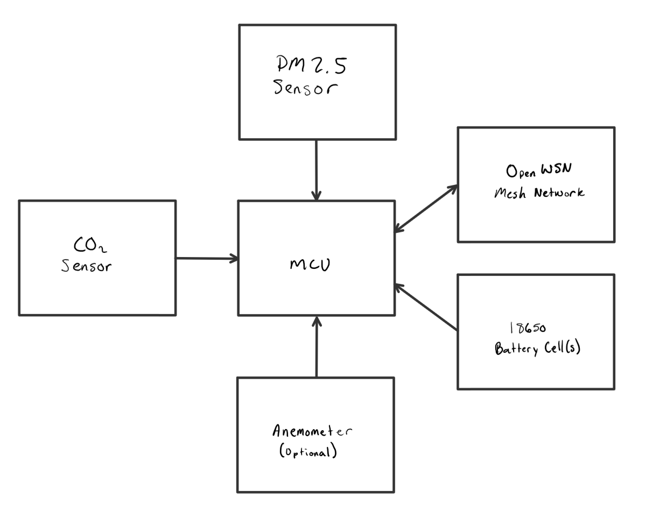

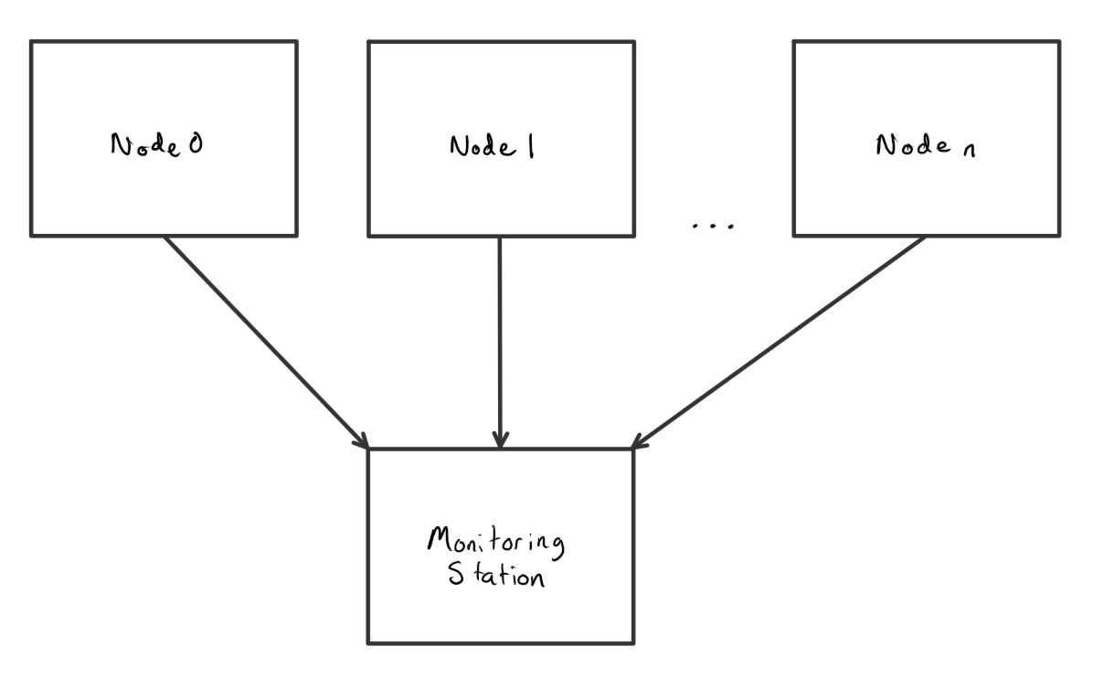

[Diagram: L1 Block Diagrams]

We have done some initial research and estimations into power consumption versus sampling rate for each of the components we have completed research on. Below are three graphs showing this data, one for each type of sensor. The dotted red line on each graph represents the average power consumption of each sensor to obtain 1 year battery life on a single 18650 Lithium Ion battery cell.

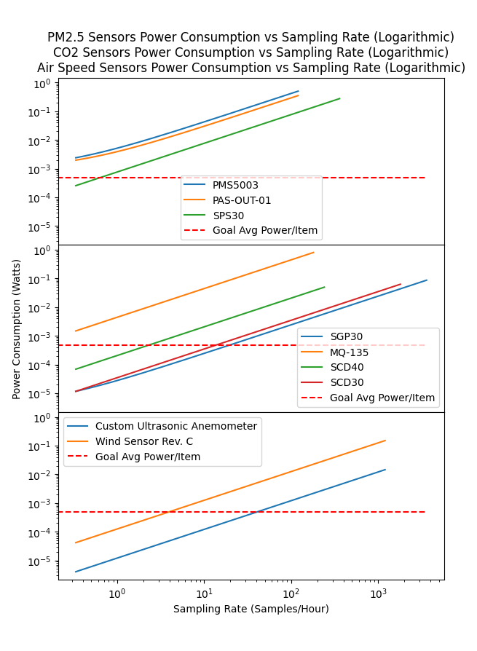

We have also completed some estimates about whole system battery life for potentially viable sensor configurations. Information on these configurations is available in section 6.1. The only sensors included in this summary are the ones that reach low enough power consumption at any point in the above graphs. Each sensor also has a different sampling rate, which is noted in the information. The configurations are sorted by lowest average power consumption per sampling rate (E.g lower power consumption is better and sampling more frequently is better)

From these calculations, it should be feasible to reach 1 year battery life, given enough batteries and/or low enough sampling rates.

For the duration of the project we are going to be performing cost-benefit analysis on several aspects of our product to determine tradeoffs in battery life as compared to project quality. The first aspect that we are weighing that has a major impact on our projects battery life is the rate at which we wake up our system and pull data from our sensors. We plan on continuing to graph and analyze this data in order to find a medium we are comfortable with. The second important tradeoff that we are looking into is power consumption in respect to the quality of our sensor, where some lower quality sensors project a better energy profile, but trade off accuracy or extra features. We will be in constant communication with Professor Burnett in order to make sure any decisions made in these respects still align with our project's goals.

### **4.7 Verification plans**

To test our project, we’re planning to run a 24-hour test run on our initial batch of 3-4 nodes, and then again later on our final batch. During these tests, we hope to see the data being collected, logged, and transmitted correctly. We also will be monitoring the power consumption of each node using EnergyTrace. Testing for 24 hours should give us a good sanity check that our design should be able to run continuously for long periods of time, both from a maintenance and battery life standpoint. This test is planned to take place in the WEST Lab in FAB 60-24.

## 

## **5. Project Management Plan**

### **5.1 Timeline, with milestones**

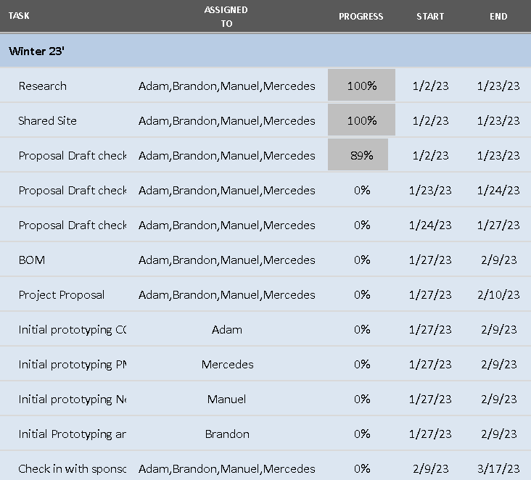

[Timelines of project - Winter]

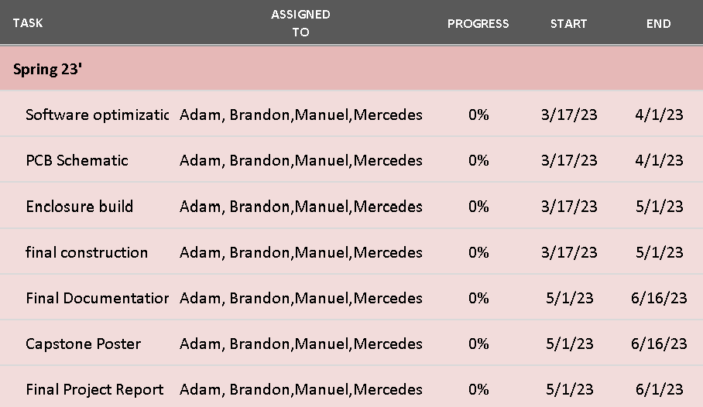

[Timeline of Project - Spring]

[Full Excel of Gantt Chart](https://github.com/brhttps://github.com/brandonhippe/412AirQualityCapstone/blob/main/Documentation/412_GanttChart.xlsxandonhippe/412AirQualityCapstone/blob/main/Documentation/412_GanttChart.xlsx)

### **5.2 Budget and Resources**

To start, the budget for this project will be $1000 with the goal of building 3-4 prototype nodes. From there, we’re estimating a cost of $300 per node, with a goal of building 10 nodes for $3000.

We will be utilizing several spaces on the Portland State University campus including but not limited to: the EPL (Electronics Prototyping Lab) for 3D printing and project assembly, Dr Burnett's research lab for meetings and project assembly, locker space in the Engineering building for project storage, and the third floor lobby of the Fariborz Maseeh Hall building for in person planning/documentation meetings. We will also utilize Zoom for meetings with our industry sponsor and our faculty advisor. For communication platforms, we will be using email to communicate with Dr Burnett and Dr Acken, and group communication will be completed via text messages, Discord, and Trello to ensure completion of projects. We will also use Github as our version control system, with a group Google Drive to share other miscellaneous items.

### 

### **5.3 Intellectual Property Discussion**

This sensor system is intended to be open source. The design, including code, schematics, guides, and other necessary design files, will be protected under the GNU General Public License v3.0, and will be freely available on the project’s github repository.

### **5.4 Team and development process**

Team Members and Skills/Project Interests:

* Adam Dezay: Documentation, Github, Wiki, Soldering, Gantt Chart.
* [Manuel Garcia](mailto:manga2@pdx.edu): KiCad Schematic & Board Layout, Programming, Web Development, General Hardware/Software Hacking, FreeCad
* [Brandon Hippe](mailto:bhippe@pdx.edu): Coding, Sensor implementation, wireless networking implementation, 3D printing, GUI development in Python and MATLAB, point of contact with sponsor
* Mercedes Newton: Team captain, Weekly report leader, 3D printing, documentation, soldering, hardware implementation, power calculations, private consulting.

We will be utilizing collaboration tools such as Trello, Github, Google Drive and Zoom. Our point person for communicating with our industry sponsor and advisor is Brandon Hippe, and our team leader is Mercedes Newton.

## **6. Appendices**

### **6.1 Configurations sorted by lowest power consumption / sampling rate**

1.

PM2.5 Sensors: SPS30

Time On: 10.0 seconds

Time Off: 5990.0 seconds

Sleep Power %: 0.0 %

Percent of Total Power: 30.73968731061792 %

CO2 Sensors: SGP30

Time On: 1.0 seconds

Time Off: 239.0 seconds

Sleep Power %: 0.9819631044825213 %

Percent of Total Power: 24.485669982102426 %

Air Speed Sensors: Custom Ultrasonic Anemometer

Time On: 3.0 seconds

Time Off: 117.0 seconds

Sleep Power %: 0.0 %

Percent of Total Power: 24.345832350009392 %

Micro Controllers: MSP430

Time On: 157.0 seconds

Time Off: 5843.0 seconds

Sleep Power %: 3.386714080587953 %

Percent of Total Power: 20.42881035727026 %

Power Consumption: 0.0014910149498333334 watts

Cost: $81.32

Battery Life on single 18650 cell: 352.10914555798706 days

2.

PM2.5 Sensors: SPS30

Time On: 10.0 seconds

Time Off: 5990.0 seconds

Sleep Power %: 0.0 %

Percent of Total Power: 28.983076061947816 %

CO2 Sensors: SCD30

Time On: 2.0 seconds

Time Off: 298.0 seconds

Sleep Power %: 0.0 %

Percent of Total Power: 26.43256536849641 %

Air Speed Sensors: Custom Ultrasonic Anemometer

Time On: 3.0 seconds

Time Off: 117.0 seconds

Sleep Power %: 0.0 %

Percent of Total Power: 22.95459624106267 %

Micro Controllers: MSP430

Time On: 177.0 seconds

Time Off: 5823.0 seconds

Sleep Power %: 3.0055627374879723 %

Percent of Total Power: 21.629762328493097 %

Power Consumption: 0.0015813826398333336 watts

Cost: $122.77

Battery Life on single 18650 cell: 331.9879621641295 days

3.

PM2.5 Sensors: SPS30

Time On: 10.0 seconds

Time Off: 5990.0 seconds

Sleep Power %: 0.0 %

Percent of Total Power: 35.594227337736676 %

CO2 Sensors: SGP30

Time On: 1.0 seconds

Time Off: 239.0 seconds

Sleep Power %: 0.9819631044825213 %

Percent of Total Power: 28.35254942748567 %

Air Speed Sensors: Wind Sensor Rev. C

Time On: 3.0 seconds

Time Off: 1197.0 seconds

Sleep Power %: 0.0 %

Percent of Total Power: 29.122549639966373 %

Micro Controllers: MSP430

Time On: 42.0 seconds

Time Off: 5958.0 seconds

Sleep Power %: 11.78666394512847 %

Percent of Total Power: 6.930673594811294 %

Power Consumption: 0.0012876619823333332 watts

Cost: $95.37

Battery Life on single 18650 cell: 407.71569495952923 days

4.

PM2.5 Sensors: SPS30

Time On: 10.0 seconds

Time Off: 5990.0 seconds

Sleep Power %: 0.0 %

Percent of Total Power: 33.71825288123783 %

CO2 Sensors: SCD30

Time On: 2.0 seconds

Time Off: 298.0 seconds

Sleep Power %: 0.0 %

Percent of Total Power: 30.7510466276889 %

Air Speed Sensors: Wind Sensor Rev. C

Time On: 3.0 seconds

Time Off: 1197.0 seconds

Sleep Power %: 0.0 %

Percent of Total Power: 27.587661448285495 %

Micro Controllers: MSP430

Time On: 52.0 seconds

Time Off: 5948.0 seconds

Sleep Power %: 9.726029993110862 %

Percent of Total Power: 7.943039042787777 %

Power Consumption: 0.0013593033273333333 watts

Cost: $136.82

Battery Life on single 18650 cell: 386.22726027599697 days

5.

PM2.5 Sensors: SPS30

Time On: 10.0 seconds

Time Off: 5990.0 seconds

Sleep Power %: 0.0 %

Percent of Total Power: 28.486206436466095 %

CO2 Sensors: SCD40

Time On: 15.0 seconds

Time Off: 1785.0 seconds

Sleep Power %: 0.0 %

Percent of Total Power: 25.637585792819483 %

Air Speed Sensors: Custom Ultrasonic Anemometer

Time On: 3.0 seconds

Time Off: 117.0 seconds

Sleep Power %: 0.0 %

Percent of Total Power: 22.561075497681145 %

Micro Controllers: MSP430

Time On: 584.0 seconds

Time Off: 17416.0 seconds

Sleep Power %: 2.7321854445696663 %

Percent of Total Power: 23.315132273033278 %

Power Consumption: 0.0016089658493333332 watts

Cost: $113.77

Battery Life on single 18650 cell: 326.2965464540662 days

6.

PM2.5 Sensors: SPS30

Time On: 10.0 seconds

Time Off: 5990.0 seconds

Sleep Power %: 0.0 %

Percent of Total Power: 33.272272921131076 %

CO2 Sensors: SCD40

Time On: 15.0 seconds

Time Off: 1785.0 seconds

Sleep Power %: 0.0 %

Percent of Total Power: 29.94504562901796 %

Air Speed Sensors: Wind Sensor Rev. C

Time On: 3.0 seconds

Time Off: 1197.0 seconds

Sleep Power %: 0.0 %

Percent of Total Power: 27.222768753652694 %

Micro Controllers: MSP430

Time On: 194.0 seconds

Time Off: 17806.0 seconds

Sleep Power %: 7.957193813706362 %

Percent of Total Power: 9.559912696198278 %

Power Consumption: 0.001377523364333333 watts

Cost: $127.82

Battery Life on single 18650 cell: 381.1187625511377 days

### **6.2 CO2 Sensor Comparisons**

|  | [SGP 30](https://www.adafruit.com/product/3709) | [SCD 30](https://www.adafruit.com/product/4867) |
| --- | --- | --- |
| Type | E CO2 | CO2 |
| Additional sensors | VOC | * Temp * Humidity |
| Range | 400-60k PPM | 0-40k PPM |
| Accuracy | ±15% | ±30PPM +3% |
| Power Consumption (On) | ~86 mW | ~63 mW |
| Price ($) | 17.50 | 58.95 |
| Relative Size | Size of quarter | Double size |

Average outdoor PPM is 414 PPM

Cities have PPM between 600-900

OSHA permits up to 5K PPM per 8 hour exposure

40K PPM is where it gets to the deadly range

ANSI recommends below 700 PPM outdoor and 1200 PPM Indoor

Sources:

[USDA](https://www.fsis.usda.gov/sites/default/files/media_file/2020-08/Carbon-Dioxide.pdf)

[SGP30 Overview/datasheet/tutorial...etc](https://learn.adafruit.com/adafruit-sgp30-gas-tvoc-eco2-mox-sensor/overview)

[SCD 30 Overview/datasheet/tutorial...etc](https://learn.adafruit.com/adafruit-scd30)

### **6.3 PM2.5 Sensor Comparisons**

|  | [PMS5003](https://shop.pimoroni.com/products/pms5003-particulate-matter-sensor-with-cable?variant=29075640352851) | [PAS-OUT-01](https://www.pranaair.com/us/air-quality-sensor/outdoor-pm-sensor/) | [PAS-IN-01](https://www.pranaair.com/air-quality-sensor/indoor-pm-sensor/) | [SPS30](https://sensirion.com/products/catalog/SPS30/) |
| --- | --- | --- | --- | --- |
| Range (concentration) | 0-500 ug/m3 | 0-31000 ug/m3 | 0-1500 ug/m3 | 0-1000 ug/m3 |
| Accuracy | ±10% or ±10 ug/m3, whichever is greater | ±10% or ±10 ug/m3, whichever is greater | ±1ug/m3, | ±10% or ±10 ug/m3, whichever is greater |
| Power Consumption (On) | ~500 mW | ~350 mW | ~350mW | ~275 mW |
| Price ($) | 39.95 | Request Quote,  student discount | Request Quote, student discount | 49.53 |
| Notes | 30 seconds before accurate data, needs calibration every 30 days | 30 seconds before accurate data | 15 seconds before accurate data, | 10 seconds before accurate data |

### 

### **6.4 Airflow Sensor Comparisons**

|  | [Custom Ultrasonic Anemometer](https://hackaday.com/2013/08/21/ultrasonic-anemometer-for-an-absurdly-accurate-weather-station/) | [Wind Sensor Rev. C](https://moderndevice.com/products/wind-sensor) |
| --- | --- | --- |
| Type | Ultrasonic | Hotwire |
| Range | Unknown and depends on size (will build and test) | 0-60 MPH |
| Accuracy | Unknown and depends on size (will build and test) | Can detect “small puff of air at a distance of 18-24 inches” |
| Power Consumption (On) | ~14.52 mW | ~150 mW |
| Price ($) | 7.90 | 21.95 |
| Relative Size | ~25-36 cm apart | .68″ × 1.590″ × .25″ |
| Notes | Requires custom design | 10 second warm-up time |